Cognifyz Data analysis Project Report :-

# Importing Libraries:-

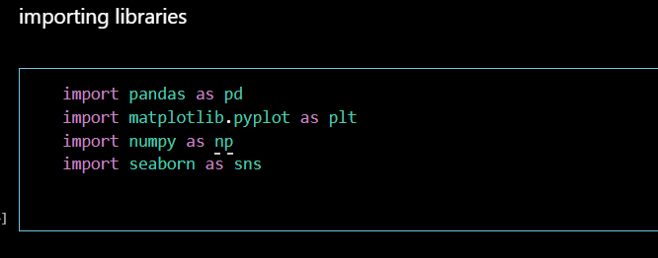

# Importing Dataset:-

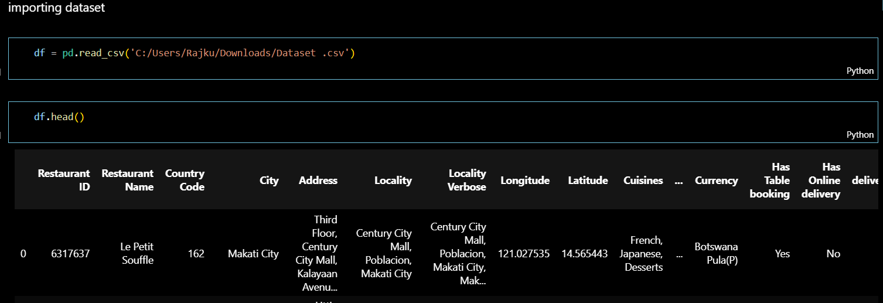

## Level 1 Task 1

## Task: 1) Top Cuisines Determine the top three most common cuisines in the dataset.

## 2) Calculate the percentage of restaurants that serve each of the top cuisines.

In this task (level 1) , we are going to determine the top 3 most commonly ordered cusines in the imported dataset .

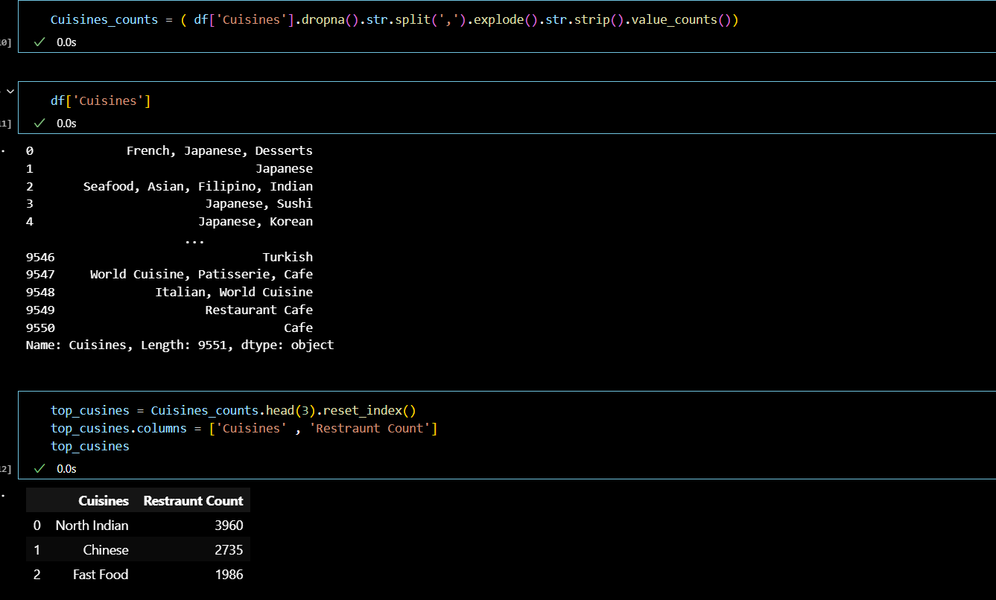

The process of plotting the Bar graph:-

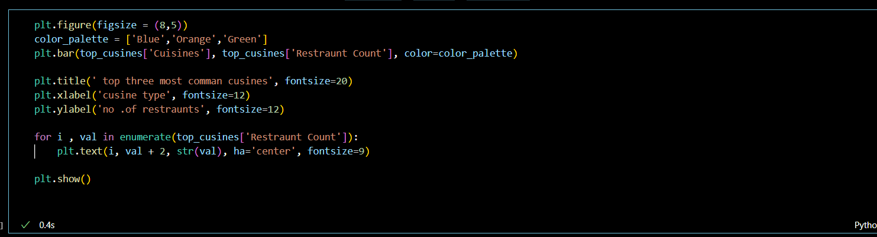

In the above diagrams we have used python program to plot the bar graph and also to calculate the percentage of restraunts that serve each of the top cusines .

North Indian cuisines are 3960

Chinese cuisines are 2735

Fast Food are 1986

These restraunts are across India and the world .

North Indian cuisine is the most served cuisine in restraunts across India and the world .

### Output:-

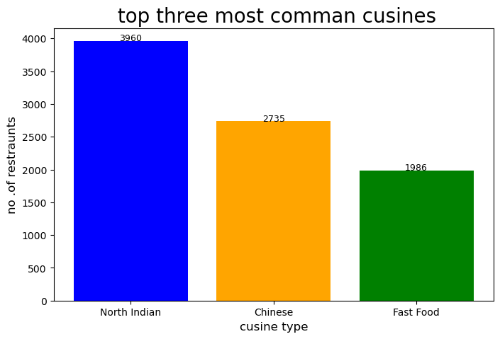

### 

Output:-

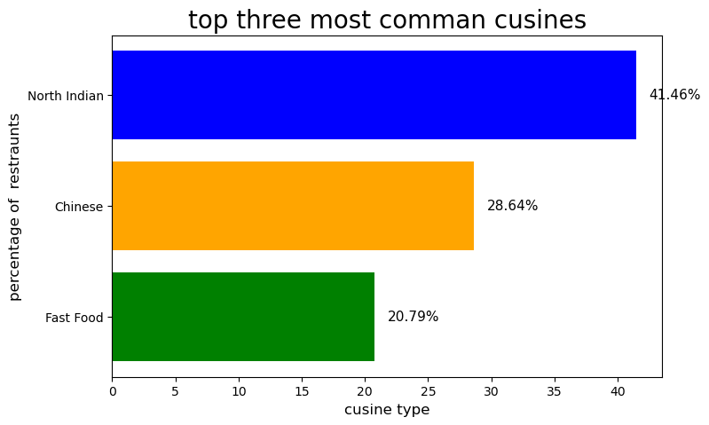

### Task 2 ,Task: City Analysis

### 1) Identify the city with the highest numberof restaurants in the dataset.

### 2) Calculate the average rating forrestaurants in each city.

### 3) Determine the city with the highestaverage rating.

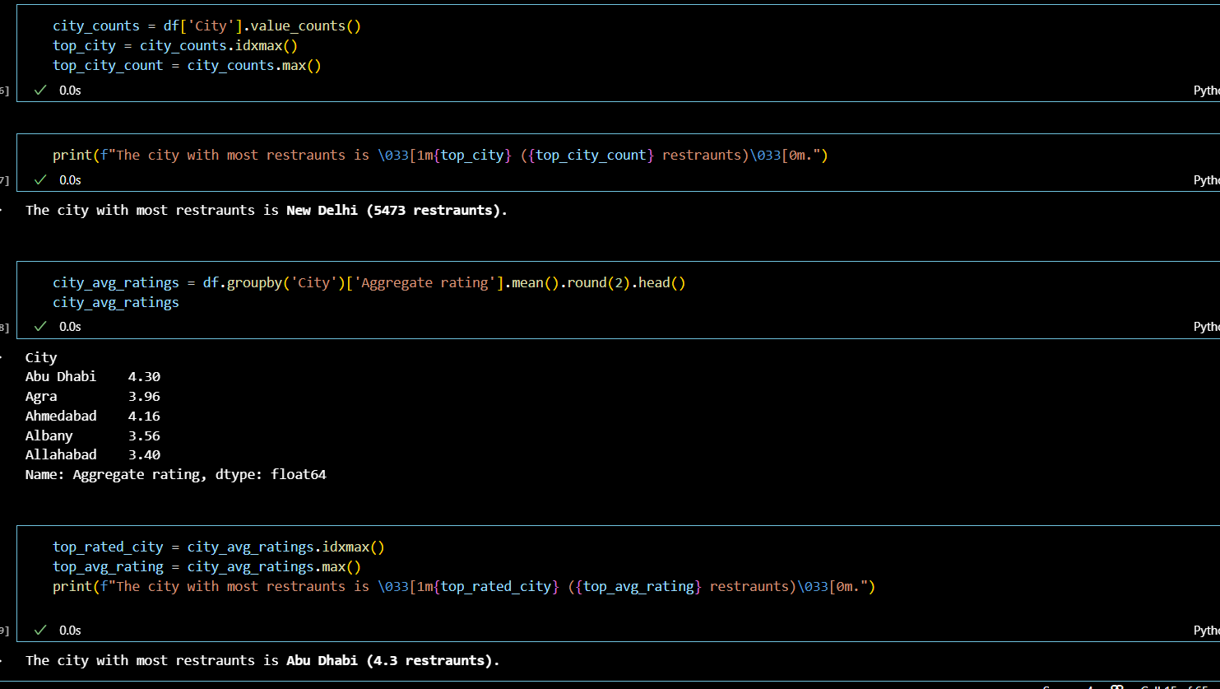

### Task 3

### Task: Price Range Distribution

### Create a histogram or bar chart tovisualize the distribution of price ranges among the restaurants

### 2) Calculate the percentage of restaurants in each price range category

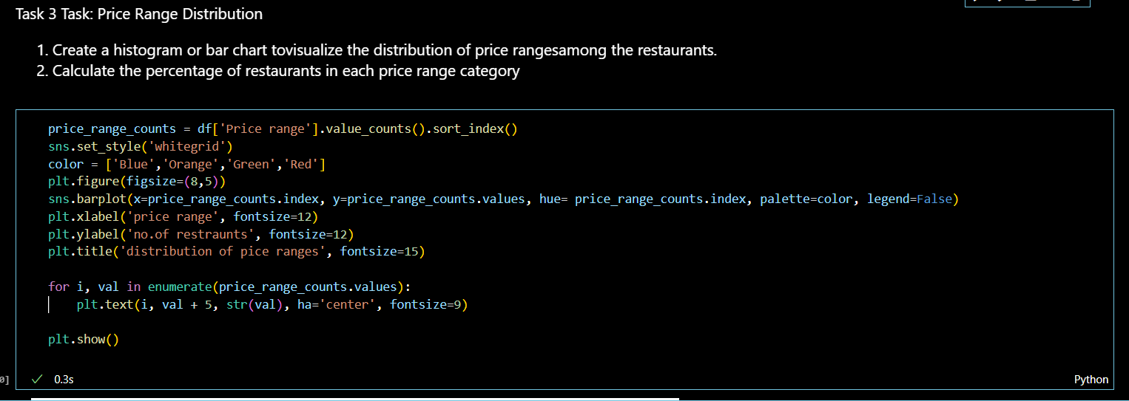In this Task we are going

### Output:-

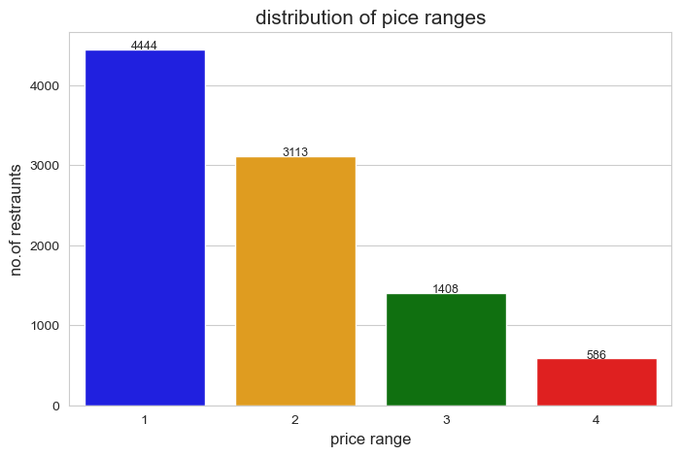

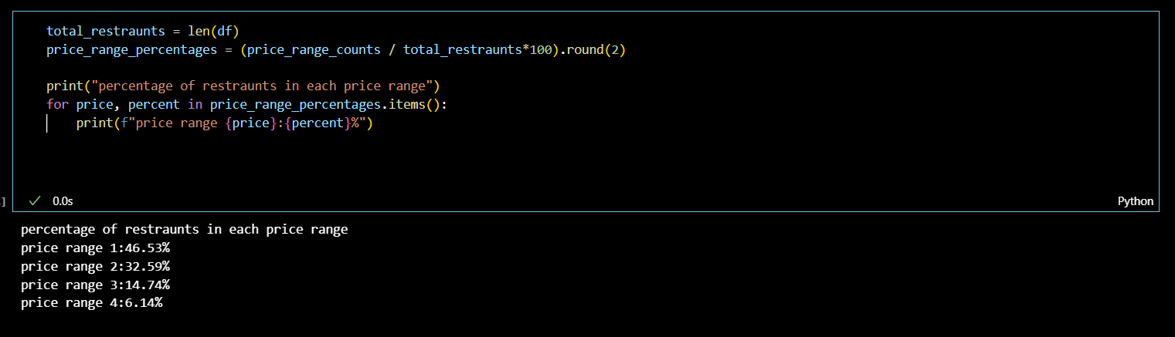

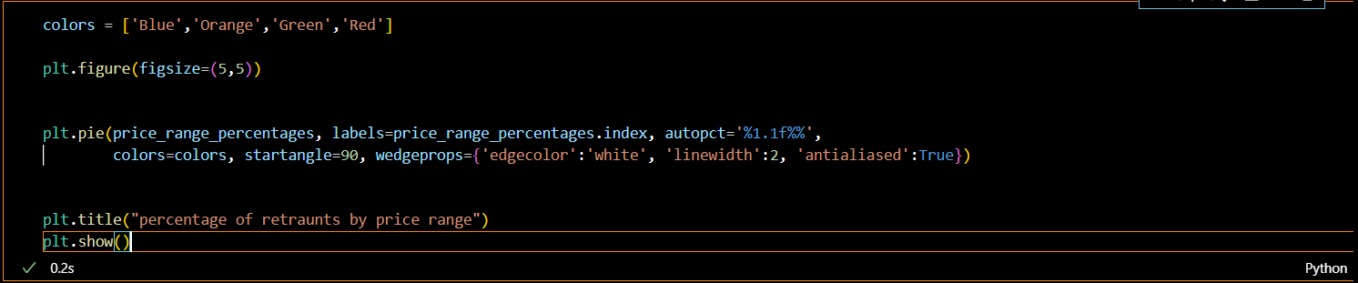Output:-

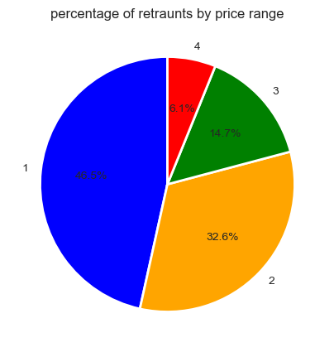

### Task 4Task: Online Delivery

### 1) Determine the percentage of restaurants that offer online delivery.

### 2) Compare the average ratings of restaurants with and without online delivery.

### 

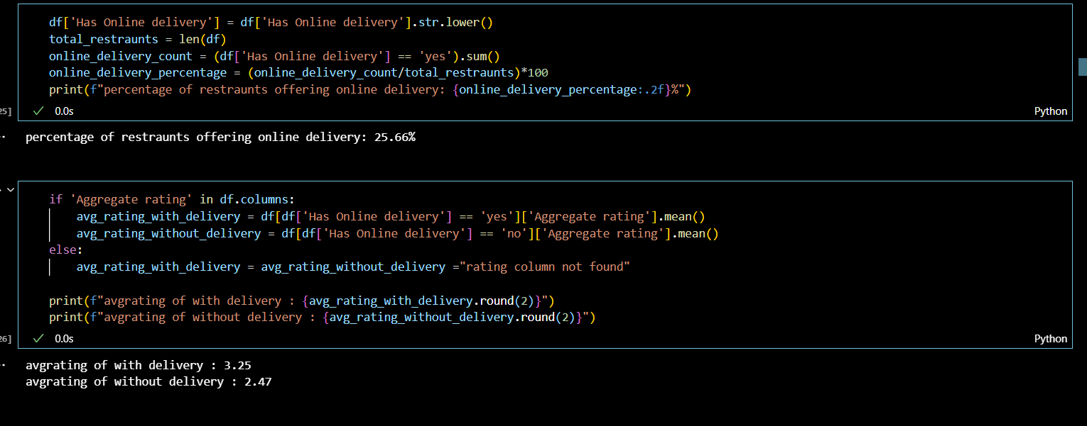

In the above diagram we have calculated the avg rating of restraunts with and without delivery.

Level 3Task 1 Task: Restaurant Reviews

### 1) Analyze the text reviews to identify the most common positive and negative keywords.

### 2) Calculate the average length of reviews and explore if there is a relationship between review length and rating

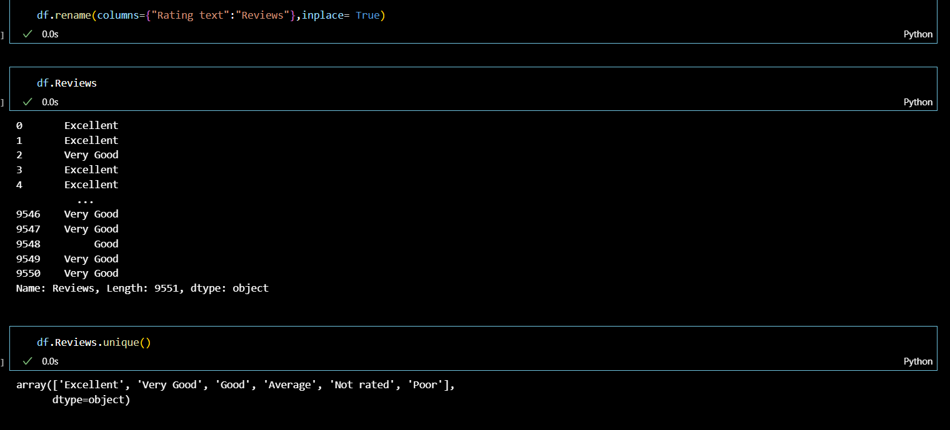

### 

Output:-

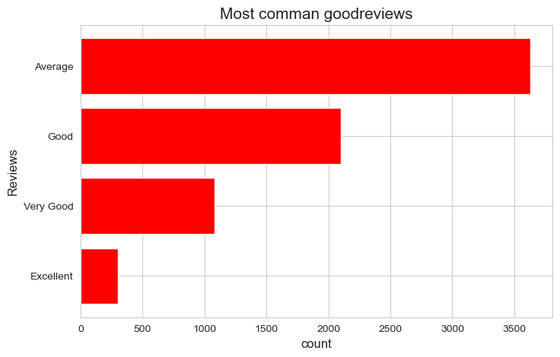

Output 2:-

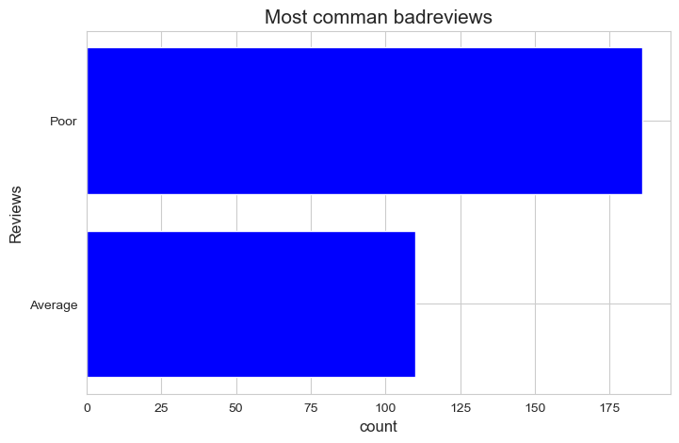

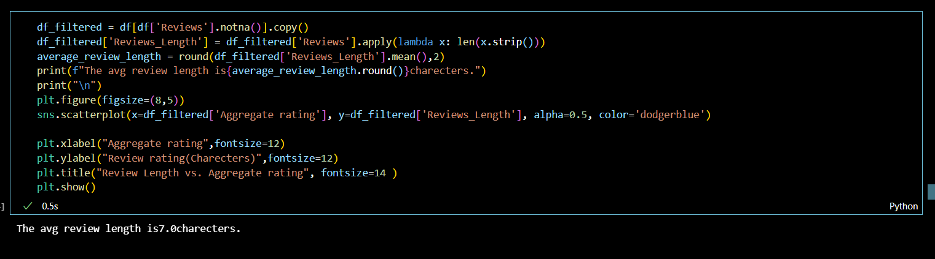

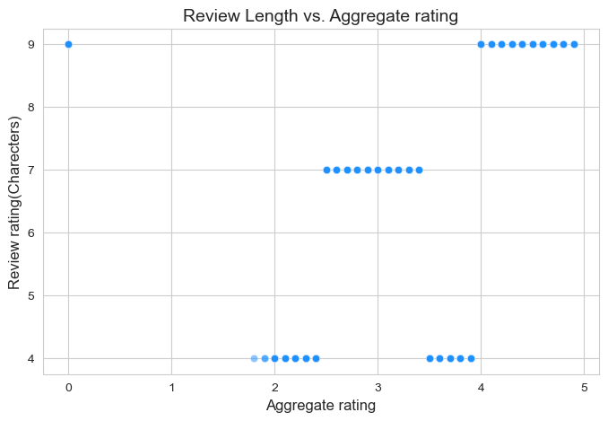

### Task 3

### Task: Price Range vs. Online Delivery and Table Booking

### 1) Analyze if there is a relationship between the price range and the availability of online delivery and table booking.

### 2) Determine if higher-priced restaurants are more likely to offer these services.

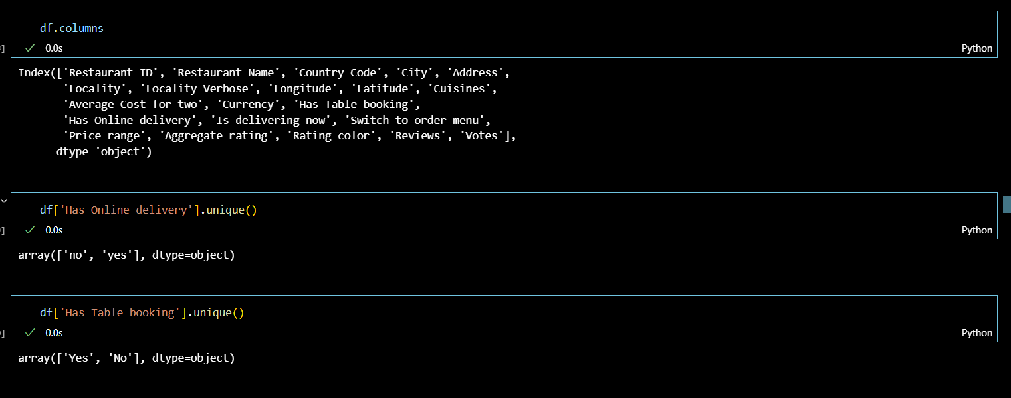

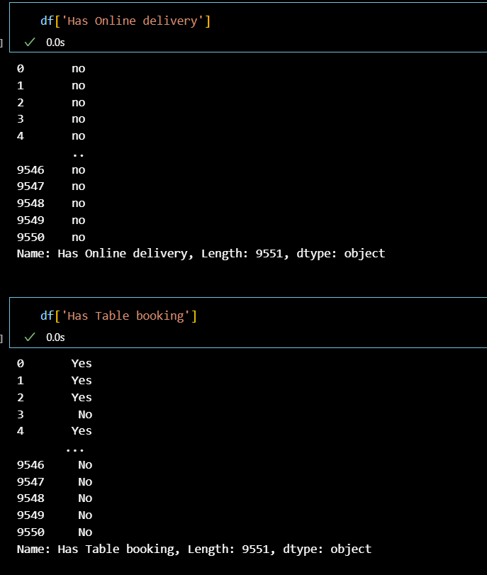

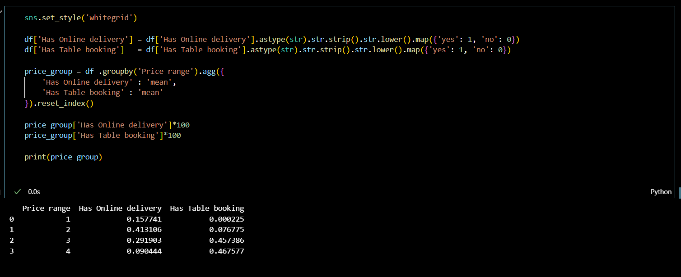

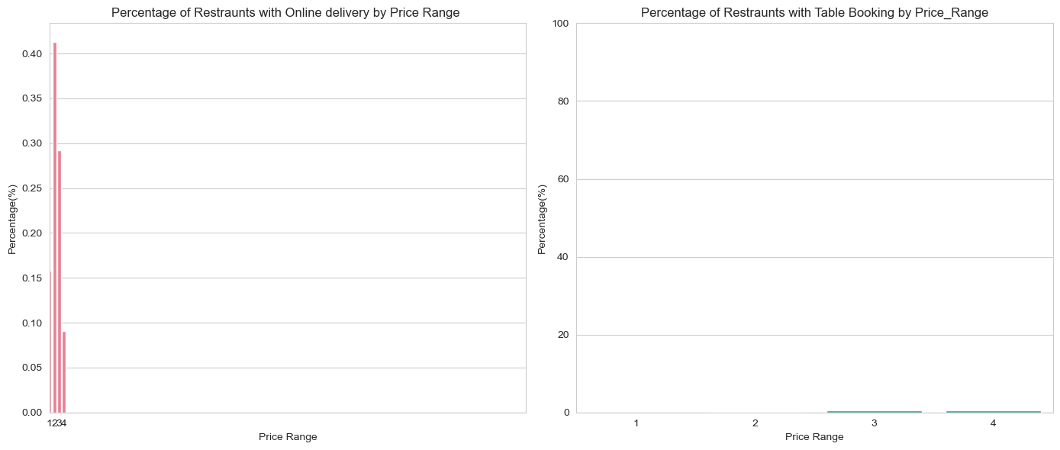

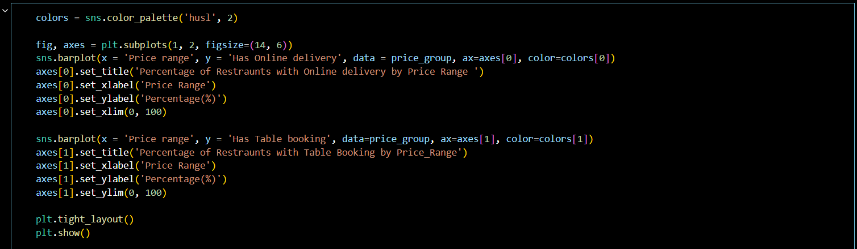

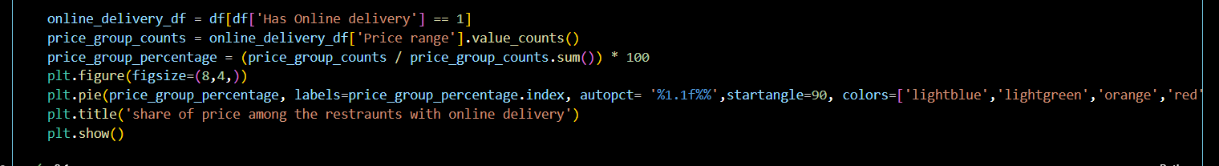

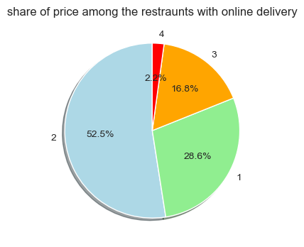Output:-

The above diagram is the pie diagram represents the share of price among the restraunts with online delivery .

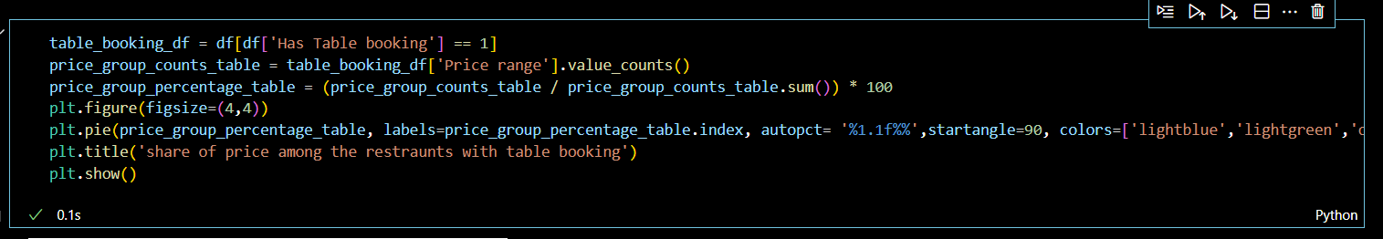

Output:-

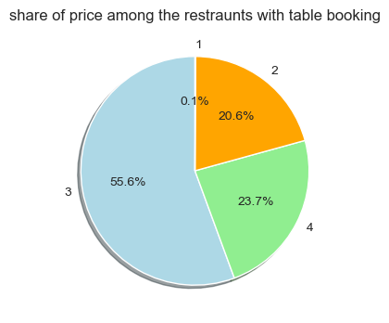

The above diagram represents the share of price among the restraunts with table booking .

### Task 2

### Task: Votes Analysis

### 1) Identify the restaurants with the highest and lowest number of votes.

### 2) Analyze if there is a correlation between the number of votes and the rating of a restaurant

### 

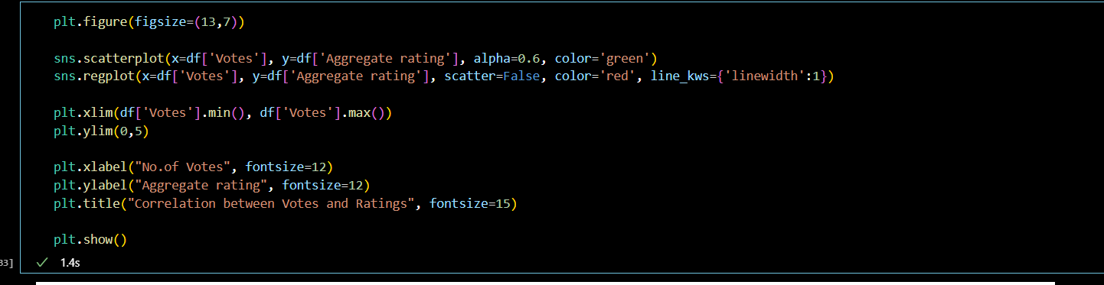

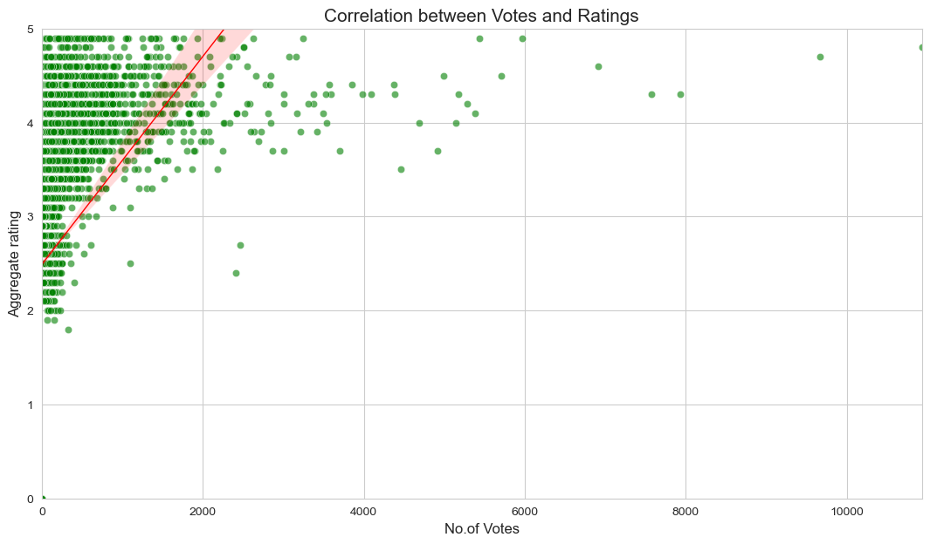

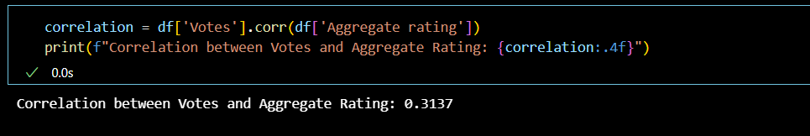

Level2:- Task1

 Task: Restaurant Ratings

 1) Analyze the distribution of aggregate ratings and determine the most common rating range.

 2) Calculate the average number of votes received by restaurants

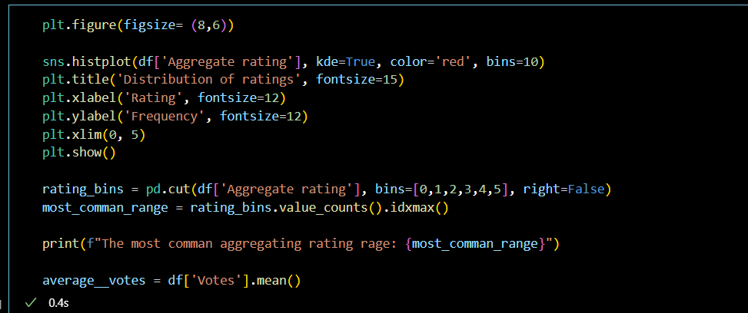

Output:-

The most comman aggregating rating rage: [3, 4)

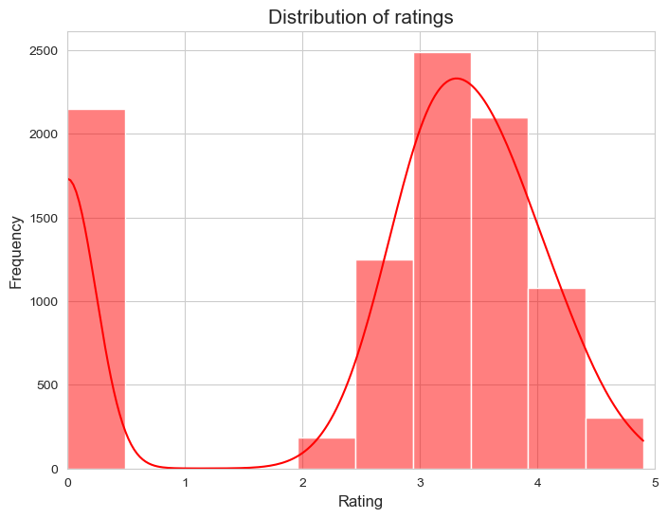

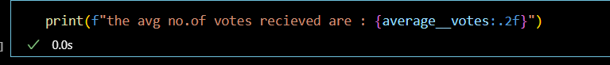

Output:-

The avg no. of votes received are : 156.91

### Task 2 Task: Cuisine Combination

### 1) Identify the most common combinations of cuisines in the dataset.

### 2) Determine if certain cuisine combinations tend to have higher ratings

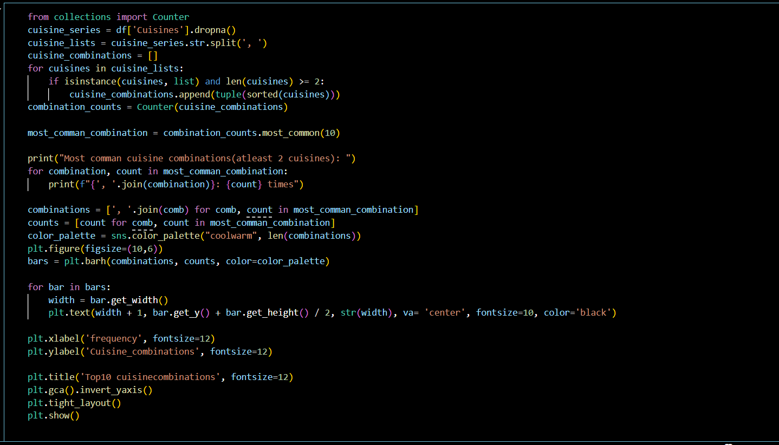

Output:-

Most comman cuisine combinations(atleast 2 cuisines):

Chinese, North Indian: 616 times

Mughlai, North Indian: 394 times

Chinese, Mughlai, North Indian: 306 times

Bakery, Desserts: 181 times

Chinese, Fast Food: 159 times

Fast Food, Pizza: 142 times

Chinese, North Indian, South Indian: 135 times

Mithai, Street Food: 134 times

Fast Food, North Indian: 120 times

Bakery, Fast Food: 117 times

These are the most commonly ordered cuisines across the world . these are top 10 most commonly ordered cuisines across the world .

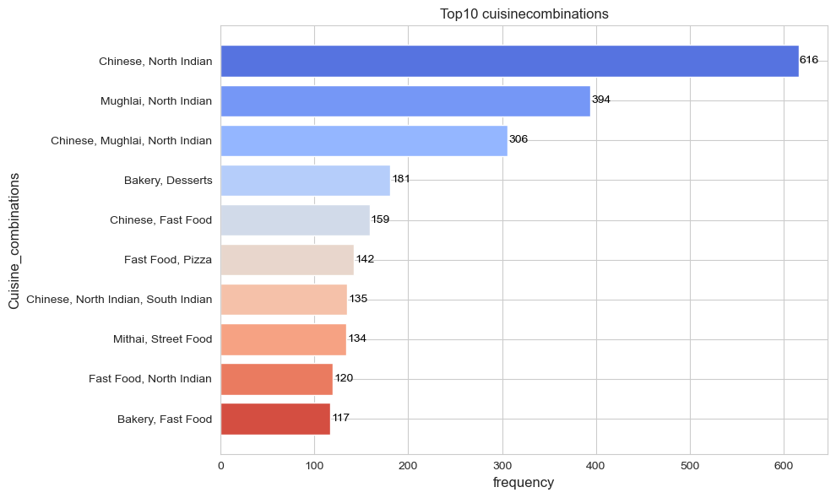

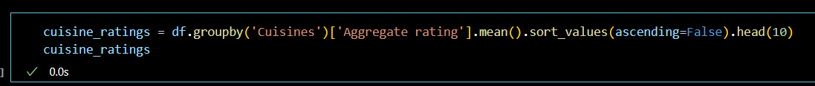

Output:-

Cuisines

Italian, Deli 4.9

Hawaiian, Seafood 4.9

American, Sandwich, Tea 4.9

Continental, Indian 4.9

European, Asian, Indian 4.9

European, Contemporary 4.9

European, German 4.9

BBQ, Breakfast, Southern 4.9

American, Coffee and Tea 4.9

Sunda, Indonesian 4.9

Name: Aggregate rating, dtype: float64

### Task 3 Task: Geographic Analysis

### 1) Plot the locations of restaurants on a map using longitude and latitude coordinates.

### 2) Identify any patterns or clusters of restaurants in specific areas

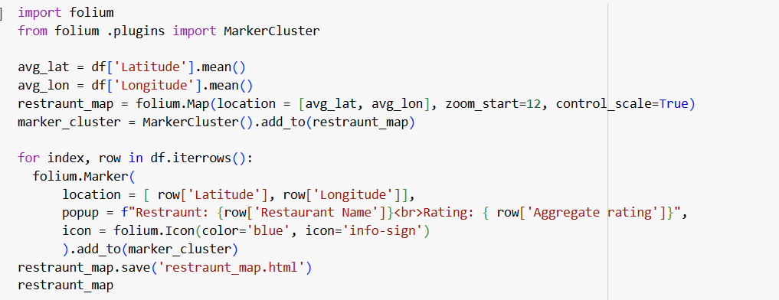

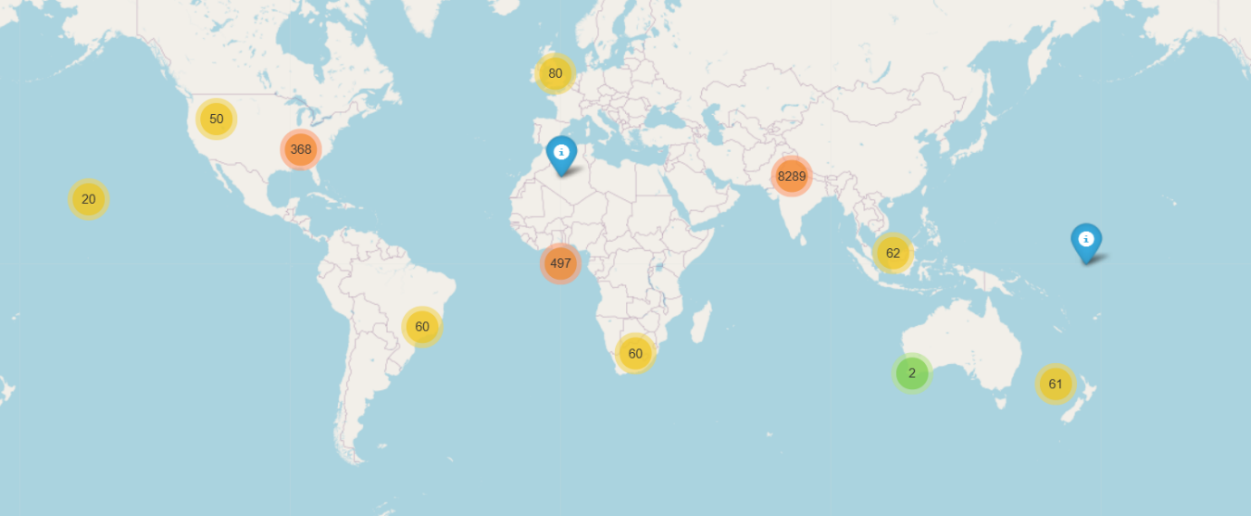

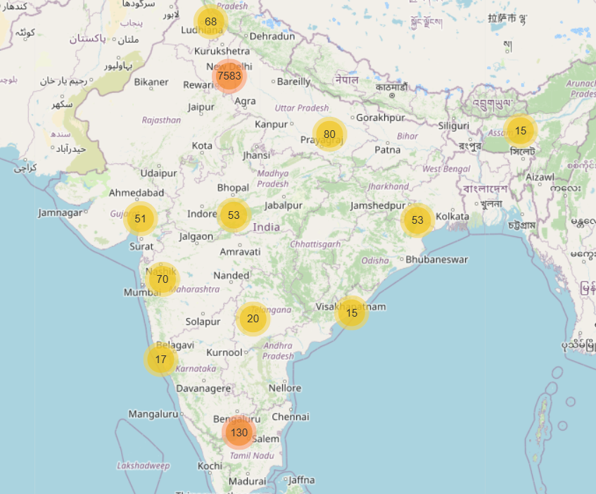

### Task 4 Task: Restaurant Chains

### 1) Identify if there are any restaurant chains present in the dataset.

### 2) Analyze the ratings and popularity of different restaurant chains

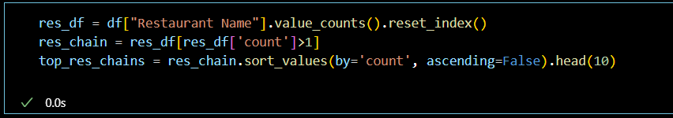

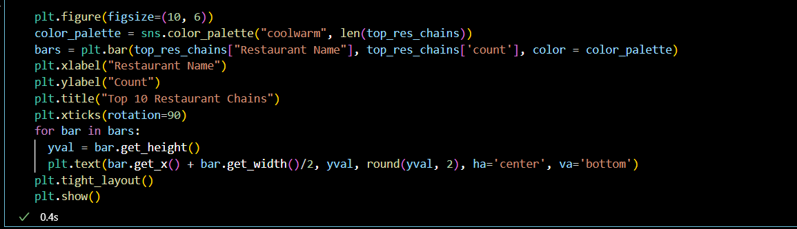

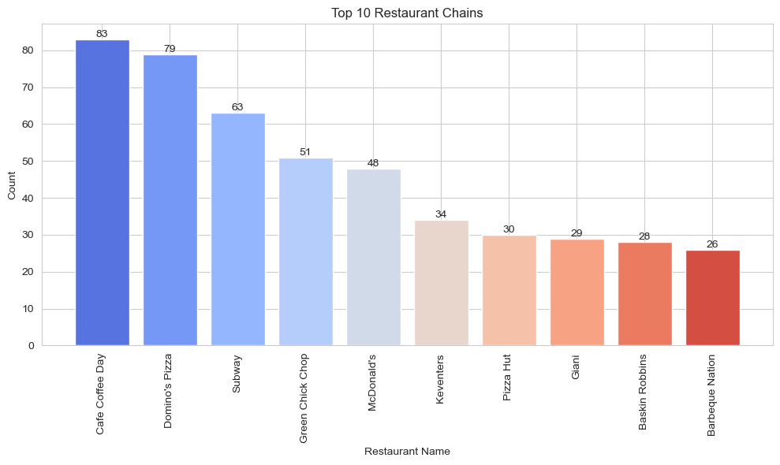

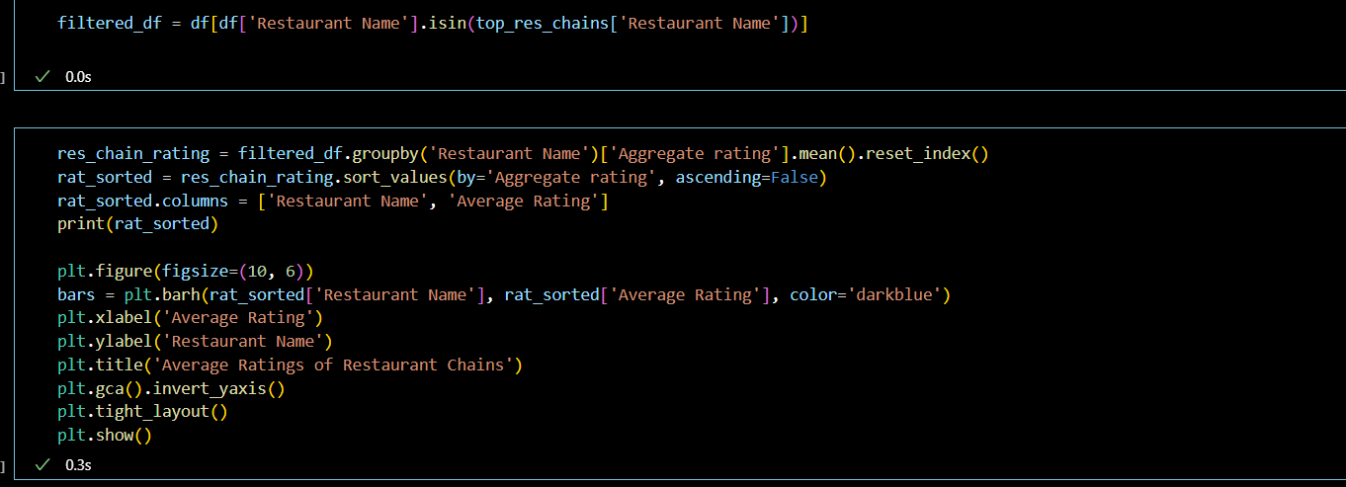

Output:-

Restaurant Name Average Rating

0 Barbeque Nation 4.353846

7 McDonald's 3.339583

8 Pizza Hut 3.320000

9 Subway 2.907937

6 Keventers 2.870588

3 Domino's Pizza 2.740506

4 Giani 2.689655

5 Green Chick Chop 2.672549

2 Cafe Coffee Day 2.419277

1 Baskin Robbins 1.860714

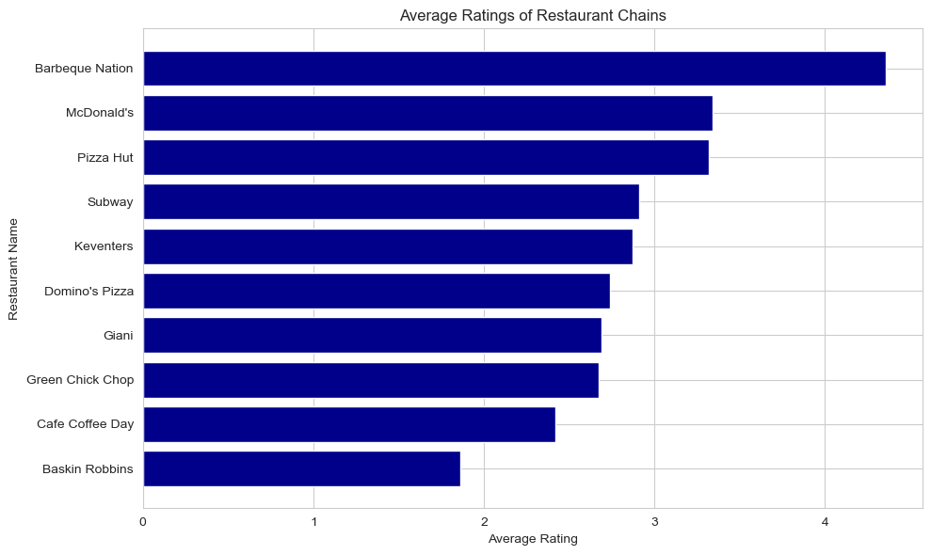

Thankyou cognifyz for the great oppurtunity, please provide me the internship certificate as soon as possible.

THE END